Low Code Development – Building things without any programming language.

Using power apps.

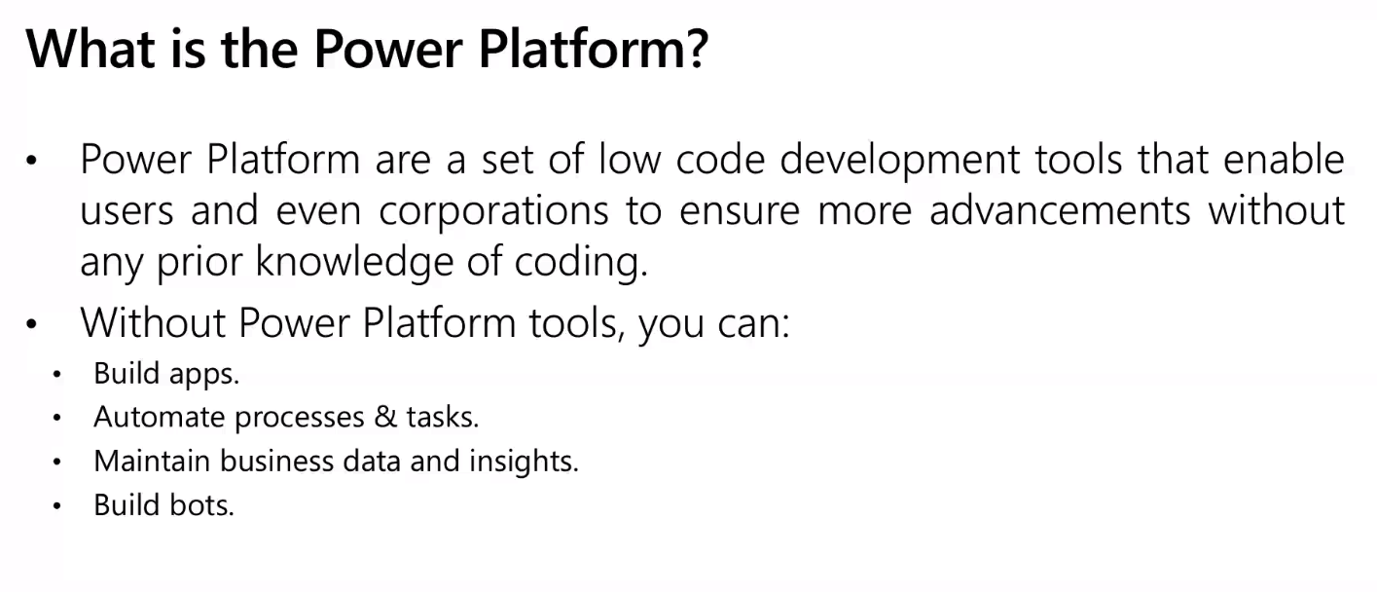

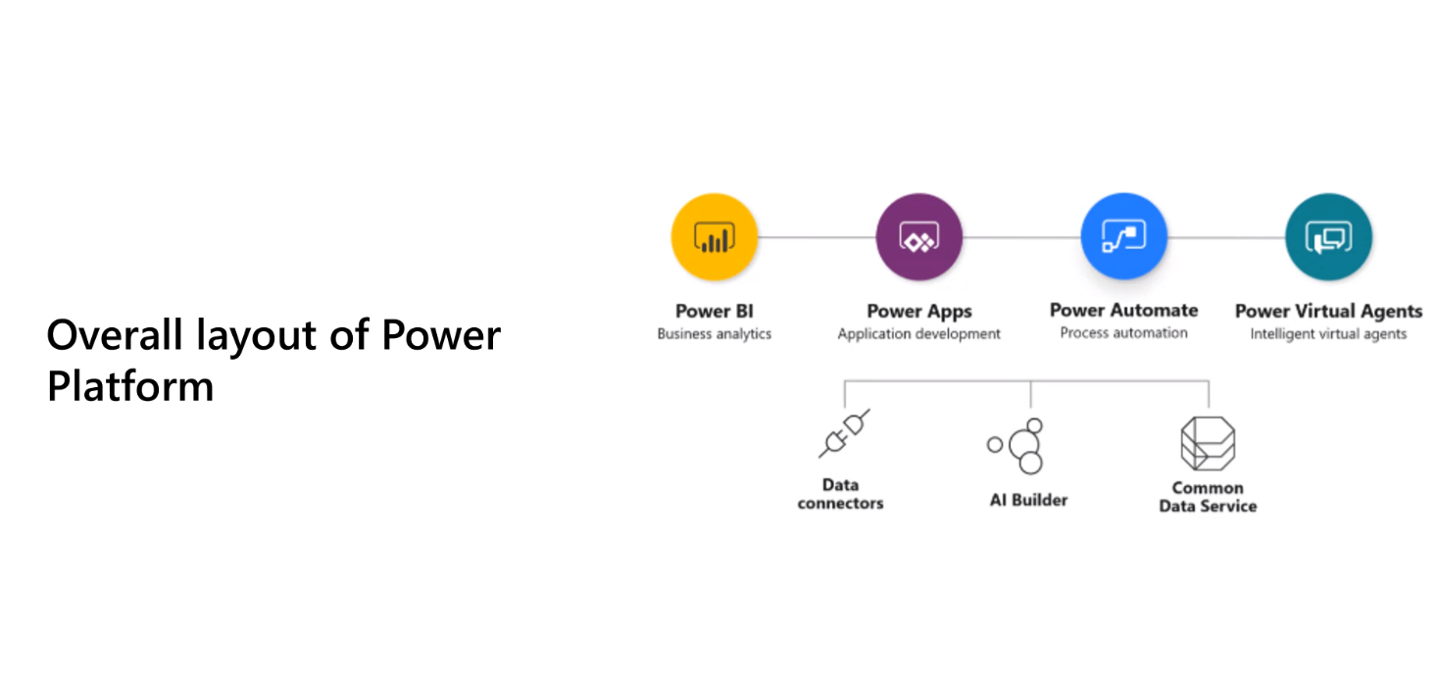

Power BI = Business Analysis

Power Apps= Enables users to build applications with zero code.

Power Automate = All about automating processes.

Power Virtual Agents= Facebook bots. When you open a website you see a bot messaging you.

Data Connectors = Just like Extensions. Taking one service and conencting it with another service. Around 275 Data connectors.

AI Builder = Train the application.

Common Data Service = Stroing the data in a certain area like, Excel sheet, csv file. Backend of analytics and process.

